Asbury Revenue Opportunity due to Vacancy- PCC

Presented to: | ThriveWell Tech / Jon Morrison, Jason Hershey
Version Number: | Draft V2
Revised Date: | 22-07-2025

Table of Contents
1 Overview 3
1.1 Project Overview 3
1.2 Asbury Communities 3
2 Project Requirements 3
3 Data Sources 4
4 ETL Process Design 4
4.1 Extraction 4
4.2 Trasformation 4
4.3 Loading 4
5 Data Mapping 4
6 Workflow and Scheduling 4
7 Error Handling and Logging 4
8 Testing and Validation 4
9 Documentation and Reporting 5
10 Maintenance and Support 5
11 Appendices 5
12 Technical Details 5
13 Qlik Reporting Sheets 5
14 UAT Cases 5
15 Changes from MyUnity 5
Version Change Control 6

1 Overview

This report provides a comprehensive analysis of the revenue opportunity resulting from vacant beds across facilities. The objective is to quantify the potential revenue loss due to unoccupied beds and highlight areas where operational improvements can drive financial gains.
The report calculates missed revenue by comparing actual occupancy against bed capacity and applying standardized bed rates. It also includes facility-level and unit-level breakdowns to identify patterns in underutilization.
1.1 Project Overview
Overview
Project Name | Asbury Revenue Opportunity due to Vacancy- PCC
Project Description | Report provides a detailed insight revenue opportunity resulting from vacant beds across facilities for all Asbury communities those who have gone to live on PCC beginning Feb’24 onwards.  Refer to Section 1.2 for Asbury Communities
Project Start Date | June 2025
Stake Holders | Jon Morrison, Jason Hershey
Additional Notes (Add as required)

1.2 Asbury Communities
Below listed are the Communities the Asbury Revenue Opportunity due to Vacancy report is prepared for.
IL - Independent Living
AL – Assisted Living
SNF - Skilled Nursing Facility
Communities | Level of Care
Asbury Solomons | IL, AL, SNF
Asbury Methodist Village | IL, AL, SNF
Bethany Village | IL, AL, SNF
Springhill | IL, AL, SNF
Riverwoods | IL, AL, SNF
Normandie Ridge | IL, AL, SNF
Asbury Grace Park | IL, AL
Asbury Ivy Gables | IL, AL
Chandler Estate | IL, AL

2 Project Requirements
This section provides the detailed Business and Technical Requirements to deliver this project.

Business Requirements:
- Quantify revenue loss associated with vacant beds across levels of care including Independent Living (IL), Assisted Living (AL), and Skilled Nursing Facility (SNF).
- Provide real-time and historical tracking of daily and Year-to-Date (YTD) vacancy and corresponding financial loss.
- Break down vacancy and loss data by facility, level of care, room type, and campus for granular analysis.
- Calculate and display KPIs such as Daily Vacancy, Daily Revenue Loss, YTD Loss, Consecutive Days Vacant, and Bed Utilization Rate.
- Normalize bed pricing by converting monthly rates to daily equivalents to ensure consistent revenue loss calculation.
- Enable trend analysis to monitor changes in occupancy and associated revenue opportunity over time.
- Highlight high-opportunity beds using conditional formatting based on vacancy duration or revenue impact.

Technical Requirements:
The technical environment and tools required to support the successful implementation of the revenue opportunity due to vacancy Report include:
Infrastructure:
- Cloud Provider: AWS
- Database: Amazon Redshift (Data Warehouse)
- Storage: AWS S3 (Raw and processed data)
- ETL Orchestration: AWS Glue
- Data Migration: AWS DMS
- ODBC Connector: NetSuite ODBC Driver for data extraction
Software:
- BI Tool: Qlik Sense
- Data Sources Integration: APIs/Connectors for:
  - Point Click Care (PCC)
  - Ultipro
  - Great Plains (GP)
  - Netsuite
  - Bed price static File (CSV, Excel)
Processing:
- ETL Framework: Custom Glue Jobs using PySpark/Scala
- Data Format: Parquet, JSON, CSV (as applicable)
- Transformation Patterns:
  - Slowly Changing Dimensions (SCD)
  - HUDI transformations for incremental data load
  - Standardization and data cleansing logic
Scheduling:
- Scheduler: AWS Glue Triggers & CloudWatch Events
- Job Timings: Twice daily (2:00 AM and 11:00 AM EST for extraction and transformation).
- For more details on job scheduling refer to Section 6.
Security & Access:
- IAM Roles for access control to Glue, S3, Redshift
- Audit Logs for ETL activity tracking
- Secure FTP for file-based data inputs
Performance Considerations:
- Optimized Redshift table designs using sort keys and distribution styles
- Monitoring via CloudWatch Metrics for ETL jobs and Redshift usage

3 Data Sources
Below listed are the data sources for this project.
- Data Sources (including type) - Point Click Care (PCC), Ultipro, Netsuite, Bed Price static file
- Format - Raw/source data
- Location – AWS S3

4 ETL Process Design

4.1 Extraction
- Source Systems: Source systems used for this report are Point Click Care (PCC), Ultipro, GP, Netsuite.
- Data Extraction Methods: AWS DMS, Netsuite ODBC Driver

4.2 Transformation
- Data Cleaning: AWS Glue used for data validation, cleansing, and standardization.
- Data Transformation Rules: Used SCD and HUDI transformations on the data in AWS Glue.

4.3 Loading
- Target Systems: AWS Redshift
- Loading Methods: AWS Glue used for loading data.

5 Data Mapping
- Source to Target Mapping: Manual mapping of source data fields to target data fields.
- Jobs
- Data mapping

6 Workflow and Scheduling
- ETL Workflow: Visual representation of the ETL process flow.
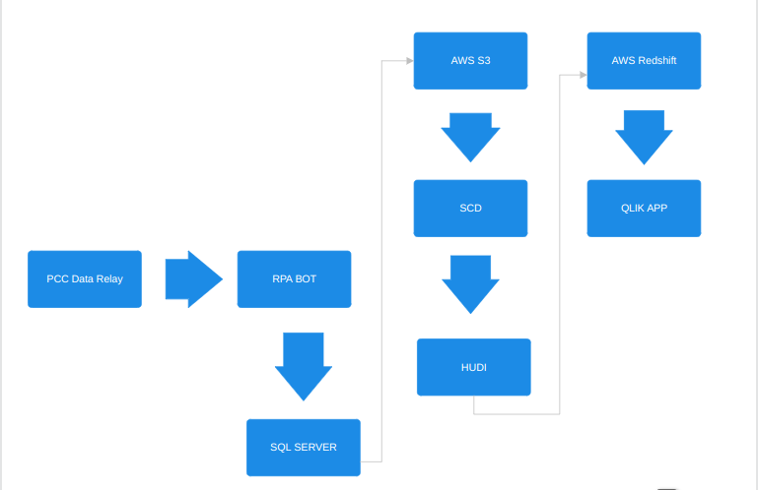
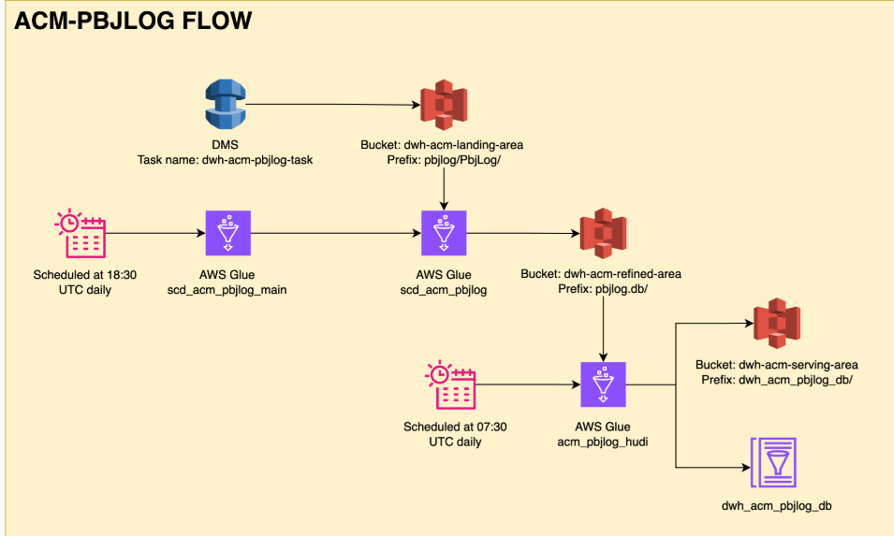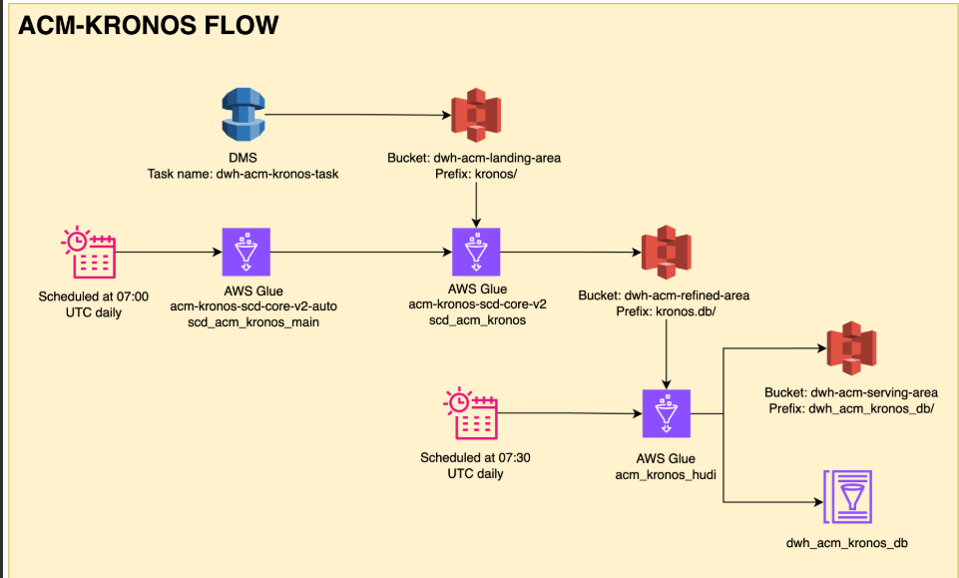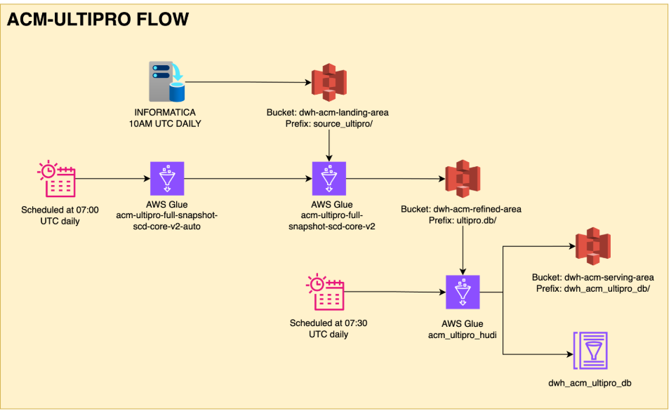
- Job Scheduling: Details on job scheduling, including frequency and dependencies.
(All timings in EST)
- Data for the backup file pulled at 0 hour (3:00 AM and 10 AM)
- 15 In FTP
- 30 Bot
- 31 File Time backup file
- 40 SQL Server loads backup file
- 00 AWS source data extraction and transformation. 55 minutes duration (scheduled at 2:00 AM and 11:00 AM)
- load Qlik (5 minutes) (scheduled at 5:45 and 11:45 AM)
- 12 PM run reports

7 Error Handling and Logging
- Error Handling Procedures: Steps to handle errors during the ETL process.
- Logging Mechanisms: Methods for logging ETL activities and errors.

8 Testing and Validation
- Test Plan: Detailed plan for testing the ETL process.
- Test Cases: Specific test cases and expected outcomes.
- Validation Procedures: Methods for validating data accuracy and completeness.

9 Documentation and Reporting
- Documentation: Comprehensive documentation of the ETL process, including code and configuration files.
- Reporting: Methods for generating and distributing reports on ETL performance and issues.

10 Maintenance and Support
Maintenance Plan
- To ensure the continued accuracy, reliability, and performance of the revenue opportunity due to vacancy Report, the Data Engineering and Analytics teams are responsible for the following ongoing maintenance activities:
- ETL Job Monitoring:
  - Regularly monitor AWS Glue job executions via CloudWatch.
  - Review logs for job failures, delays, or data quality issues.
- Redshift Performance Tuning:
  - Monitor table sizes, query performance, and vacuum operations.
  - Perform regular optimizations, including updating statistics, sort keys, and distribution styles.
- Data Quality Checks:
  - Implement automated validation rules (e.g., row count checks, null checks).
  - Schedule periodic audits to ensure data integrity.
- Security Reviews:
  - Review IAM roles and access permissions quarterly.
  - Monitor and log unauthorized access attempts.
- Data Source Connectivity:
  - Maintain and update ODBC drivers, APIs, and DMS connectors as needed.
  - Test integration endpoints and credentials regularly to avoid failures.
- System Upgrades:
  - Stay current with AWS Glue, Redshift, and Qlik updates and patches.
  - Validate report compatibility after upgrades or new feature releases.
- Backup File Management:
  - Ensure timely ingestion of backup files from FTP locations.
  - Validate backup file structure and content before processing.
Support Procedures
- The support team will follow a structured escalation and resolution procedure to handle production issues efficiently:
- Issue Identification:
  - Detected through automated alerts (AWS CloudWatch), manual user reports, or scheduled audits.
- Logging and Tracking:
  - All issues logged in the internal ticketing system (e.g., Jira, ServiceNow) with timestamps, severity levels, and assigned owners.
- Resolution Timeline:
  - Critical issues (e.g., ETL failure, Redshift down, Qlik not loading): Resolved within 2–4 hours.
  - Medium issues (e.g., delayed reports, data mismatch): Resolved within 1 business day.
  - Low-priority issues (e.g., enhancements, formatting requests): Resolved within 3–5 business days.
- Communication Protocol:
  - Immediate stakeholders (Jon Morrison, Jason Hershey) are notified in case of any production delays or critical issues.
  - Resolution summaries are shared via email or Teams after ticket closure.
- Knowledge Base:
  - Maintain and update SOPs (Standard Operating Procedures) for frequent issues and recurring support tasks.
  - Documentation is stored in a shared Confluence or SharePoint location accessible by the support team.
- Post-Incident Review:
  - A root cause analysis (RCA) is performed for high-severity issues.
  - Lessons learned and preventive measures are documented and shared with the team.

11 Appendices

11.1 Glossary:
Term / Acronym | Definition
Vacancy | The number or percentage of available beds in a healthcare facility that are not currently occupied by patients. It represents the unused bed capacity at a given point in time and is a key metric for measuring facility utilization and potential revenue opportunities.
PCC (PointClickCare) | A cloud-based EHR platform used by senior care providers for clinical and financial data management.
ETL (Extract, Transform, Load) | A data integration process for extracting data from sources, transforming it, and loading it into a target system.
HUDI | Hadoop Upserts Deletes and Incrementals – used for incremental data processing and versioning.
SCD (Slowly Changing Dimension) | A data warehousing concept used to manage and track changes in dimension tables over time.
AWS Glue | A serverless data integration service for discovering, preparing, and combining data.
Redshift | Amazon's cloud-based data warehouse solution for large-scale data storage and analytics.
Qlik Sense | A Business Intelligence tool used for creating interactive reports and dashboards.
Occupancy Rate | The ratio of occupied beds to total beds in a facility.
IAM (Identity and Access Management) | AWS service used to manage access to AWS services and resources securely.
CloudWatch | AWS monitoring and observability service for cloud resources and applications.
DMS (Database Migration Service) | AWS service for migrating databases from on-premises to AWS cloud.
FTP (File Transfer Protocol) | A standard network protocol is used to transfer files from one host to another.

11.2 References:
Resource | Description
PointClickCare Documentation | Official reference for APIs, data structures, and integration methods with PCC.
AWS Glue and Redshift Documentation | AWS technical resources for Glue job development and Redshift configuration.
Qlik Sense Developer Hub | Documentation and community forum for Qlik scripting, visualization, and reporting.
Asbury Community Guidelines | Internal documentation outlining reporting needs and community structure.
Healthcare Data Compliance Guidelines | HIPAA and other relevant data governance requirements.
Internal Data Dictionaries and Mapping Sheets | Source-to-target mappings, data definitions, and ETL transformation logic maintained by the data team.

12 Technical Details
The technical details include:
Tables, Procedures and Views:
Tables | Procedures | Views
Date table | dim.load_datetable(); | Vwbed
Entity | dim.load_entity(); | Vwcensus
Facility | dim.load_facility(); | Vwbuilding
Campus | dim.load_campus(); | Vwbedoccupancy
Campus active dates | dim.load_campusactivedates(); | Vwbedoccupancy2ndperson
Level-of-care | dim.load_levelofcare(); | Vwdate
Building | dim.load_building(); | Vwdischarges
Unit | dim.load_unit(); | Vwbedprice
Room | dim.load_room();
Bed | dim.load_bed();
Resident | dim.load_resident();
Admission action | dim.load_admissionaction ();
Admission status | dim.load_admissionstatus ();
Admission | dim.load_admission();
Bed occupied | dim.load_bedoccupied();
Bedavailable | dim.load_bedavailable(); dim.update_bedavailable();
BedOccupancy | dim.load_bedoccupancy();
Census | dim.load_census();
Bed Price | dim.load_bedprice()

13 Qlik Reporting Sheets
Please find attached spreadsheets for the Qlik reporting sheets.
Below is the link to the reporting tool
Revenue_Opportunity_due_to_Vacancy _Qlik_Report

14 UAT Cases
Test Case ID | Test Scenario | Test Steps | Expected Result
TC01 | Validate Revenue Opportunity Calculation | 1. Open report2. Select a specific facility and date3. Manually calculate opportunity = Unoccupied Beds × Bed Rate | Reported revenue opportunity matches manual calculation
TC02 | Validate Bed Capacity vs Occupancy | 1. Select a facility2. Check total bed count and occupied bed count3. Calculate vacancy = Total Beds - Occupied Beds | Vacancy count in report matches the difference
TC03 | Filter by Facility | 1. Select different facilities from the filter | Only selected facility's data is shown
TC04 | Filter by Date Range | 1. Apply a specific date range (e.g., June 2025)2. Review data for that period | Only records within the selected date range are shown
TC05 | Validate Aggregated Monthly Values | 1. Switch to monthly aggregation2. Check if revenue opportunity totals are correct | Monthly figures are accurate sums of daily values
TC06 | Filter by Level of Care | 1. Select one or more care levels (e.g., SNF, Rehab)2. Review resulting data | Report displays only selected care levels and updates calculations
TC07 | Cross-verify Bed Rate | 1. Select a specific unit2. Verify that the applied rate matches the configured rate from the pricing table | Bed rate used in calculation matches backend rate logic
TC08 | Validate Totals in Summary Section | 1. Scroll to summary/footer section of report2. Validate total opportunity vs individual line items | Summary totals correctly reflect detailed rows
TC9 | Role-based Access (RLS Validation) | 1. Log in with a user tied to a specific facility2. Check data visibility | User can only see data for their assigned facility

15 KPI
Revenue_opportunity_due_to_vacancy KPI's (Includes Daily Occupancy KPI’s), additional KPI’s are listed below.

KPI Name | Definition | Formula / Logic
Total Vacancy on Current Date | Total number of unoccupied beds across all levels of care (IL, SNF, AL) as of the current date | Total Vacancy = Total Beds - Occupied Beds (for today)
IL Vacancy on Current Date | Total number of unoccupied beds in Independent Living (IL) as of the current date | IL Vacancy = IL Beds - IL Occupied Beds (for today)
SNF Vacancy on Current Date | Total number of unoccupied beds in Skilled Nursing Facility (SNF) on the current date | SNF Vacancy = SNF Beds - SNF Occupied Beds (for today)
AL Vacancy on Current Date | Total number of unoccupied beds in Assisted Living (AL) on the current date | AL Vacancy = AL Beds - AL Occupied Beds (for today)
Total Loss on Current Date | Potential revenue loss due to vacant beds on the current date, across all care levels | Loss = Total Vacancy × Bed Rate (per level of care)
IL Loss on Current Date | Revenue loss from vacant IL beds on the current date | IL Loss = IL Vacancy × IL Bed Rate
SNF Loss on Current Date | Revenue loss from vacant SNF beds on the current date | SNF Loss = SNF Vacancy × SNF Bed Rate
AL Loss on Current Date | Revenue loss from vacant AL beds on the current date | AL Loss = AL Vacancy × AL Bed Rate
YTD Vacancy | Cumulative count of all unoccupied beds from the start of the year to current date | YTD Vacancy = SUM(Vacant Beds) from Jan 1 to Today
YTD Loss | Total missed revenue due to vacant beds YTD | YTD Loss = SUM(Vacant Beds × Bed Rate) from Jan 1 to Today
Vacant | Boolean indicator showing if a bed is currently unoccupied | Vacant = IF(Occupancy Status = 0, THEN 'Yes', ELSE 'No')
Consecutive Days Vacant | Number of continuous days a bed has remained unoccupied | Count number of continuous previous days (including today) where Occupancy Status = 0, ordered by date

16 Reported Issues
1. In the report, bed pricing is sourced from two different rate structures: daily rates and monthly rates. To ensure consistency and accuracy in financial calculations—such as vacancy-related revenue loss—all rates must be normalized to a daily rate format. For beds associated with a monthly rate, the daily equivalent is calculated by dividing the monthly rate by the number of days in the respective month. This ensures alignment between daily occupancy data and daily revenue opportunity metrics.
Normalization Formula: Daily Rate = Monthly Rate / Number of Days in Month .

Version Change Control
Version | Change | Date  (Mo-Day-Year) | Updated  By
Draft V1 | Created draft version of vacancy Revenue Report | 11-07-2025 | Vaishnavi Lakhera
Draft V1 | Updated community details, Qlik Screenshots, Overview | 11-07-2025 | Vaishnavi Lakhera
Draft V1 | Updated Qlik report snapshots and its link and data sources | 11-07-2025 | Vaishnavi Lakhera
Draft V1 | Updated points highlighted in the mail: 4,5,6,7,10 | 11-07-2025 | Siddharth Mittal
Draft V2 | Updated Jobs and data mapping details | 11-07-2025 | Vaishnavi Lakhera
Draft V2 | Updated data workflow | 22-07-2025 | Vaishnavi Lakhera

